SPRINT - 1

|  |  |
| --- | --- |
| **TEAM ID** | **PNT2022TMID11540** |
| **PROJECT NAME** | **IOT BASED SMART CROP PROTECTION SYSTEM**  **FOR AGRICULTURE.** |
| **MAX MARKS** | **20 MARKS** |

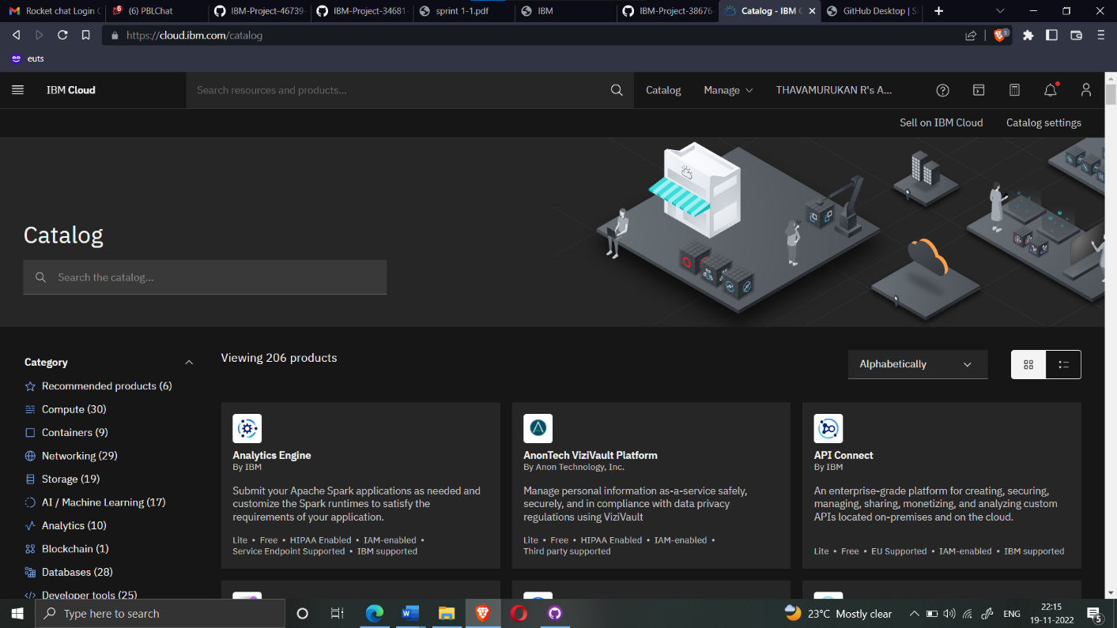

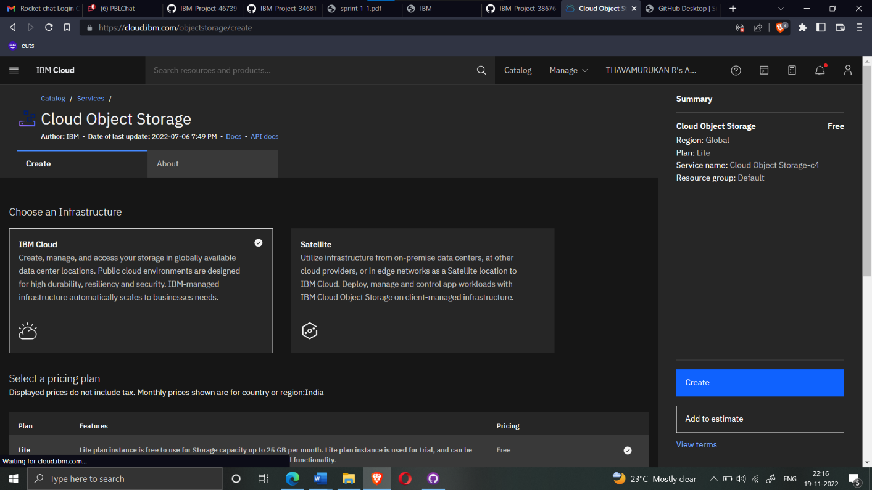

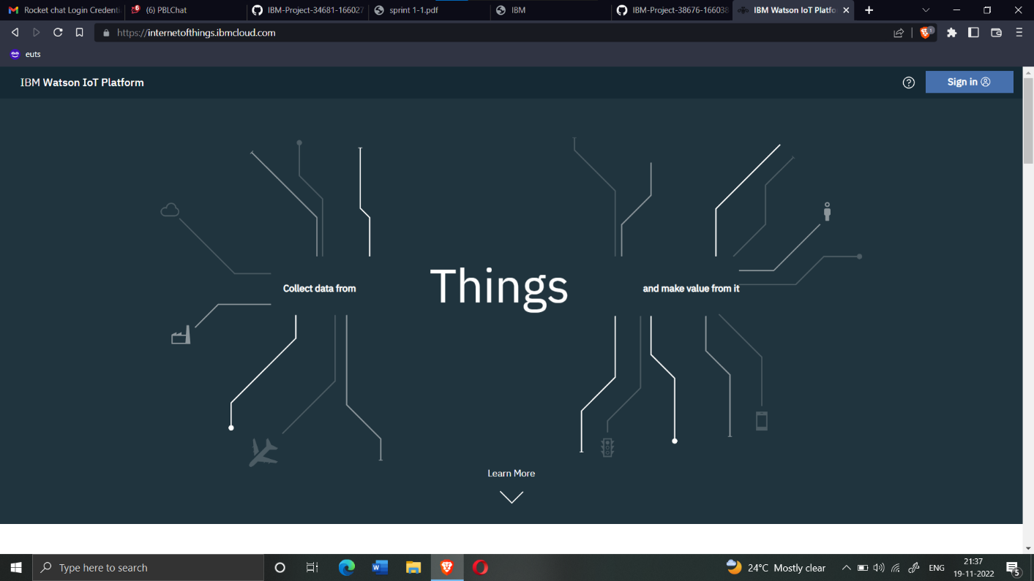

DEVICE CREDENTIALS INFORMATION :

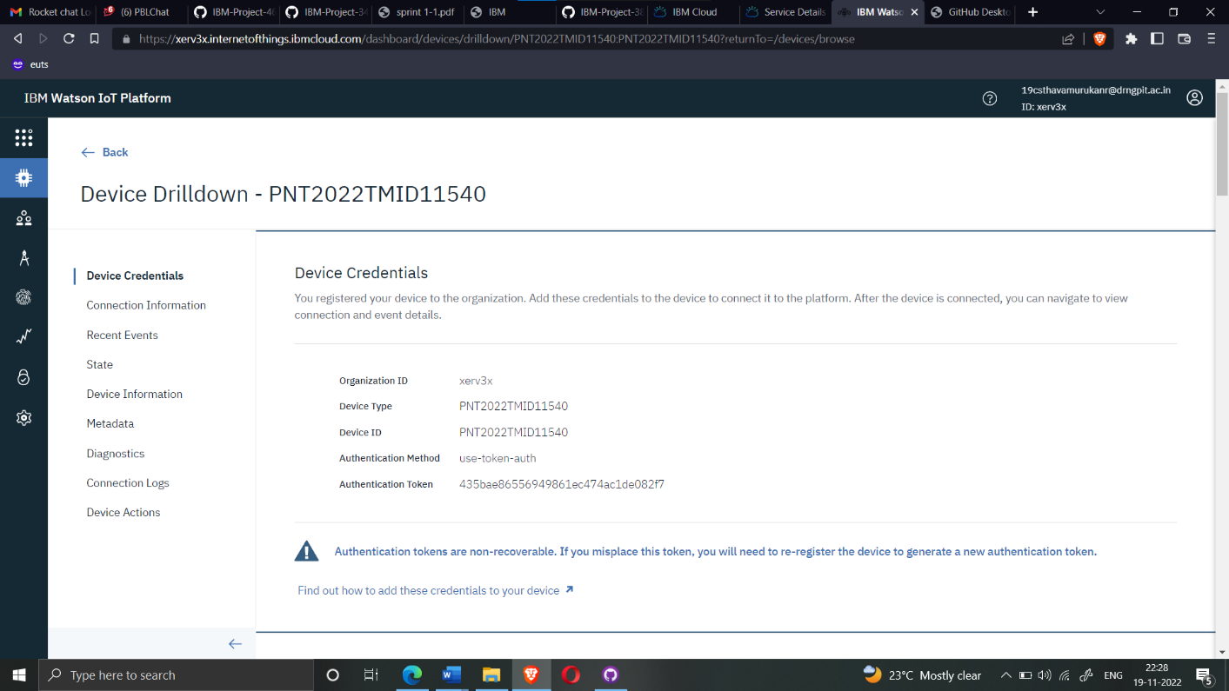



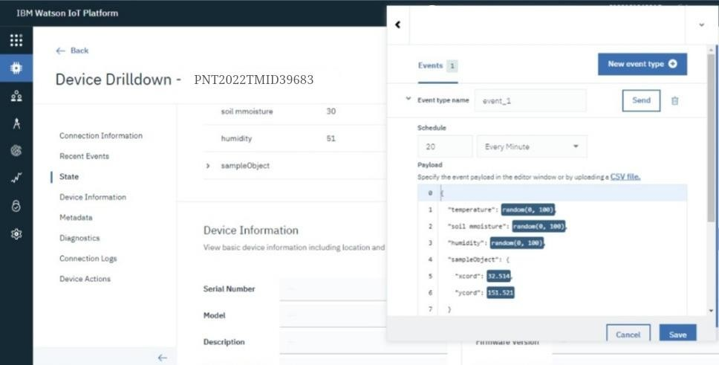



OUTPUT :

